**System Implementation Structures :**

System Implementation Structures are the lowest-level system elements in the system hierarchy (system breakdown structure).

The implementation Structure starts with how the pages are displayed as soon as the application starts running.

The application opens begins with the Home Page, Which asks the authorized user(Pharmacist/Manager/Executive Manager) to login.

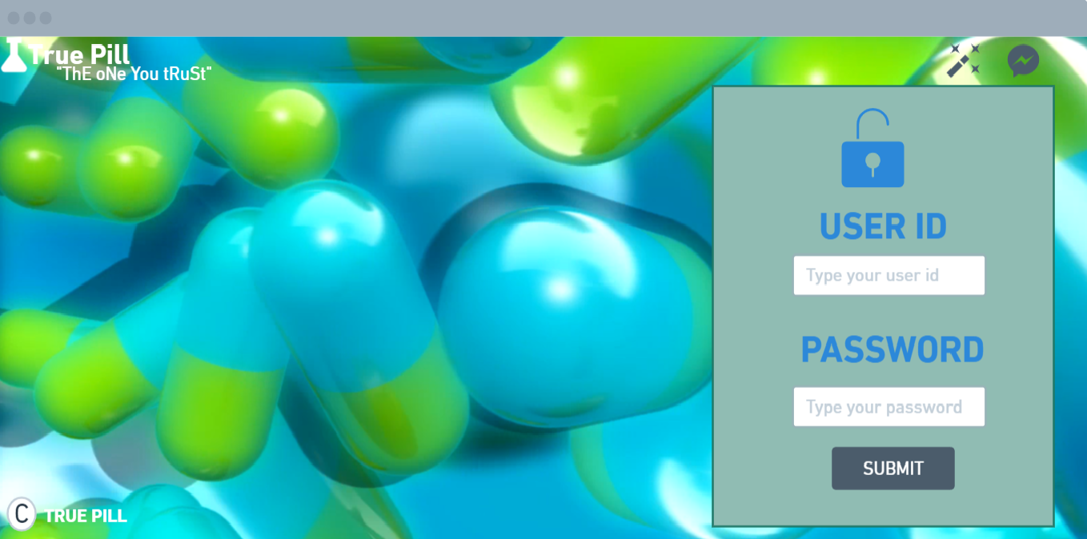

If the user logged in is a Pharmacist, then the homepage of the Pharmacist is displayed.

**string sql= select * from pharmacist where username==?&& password==?**

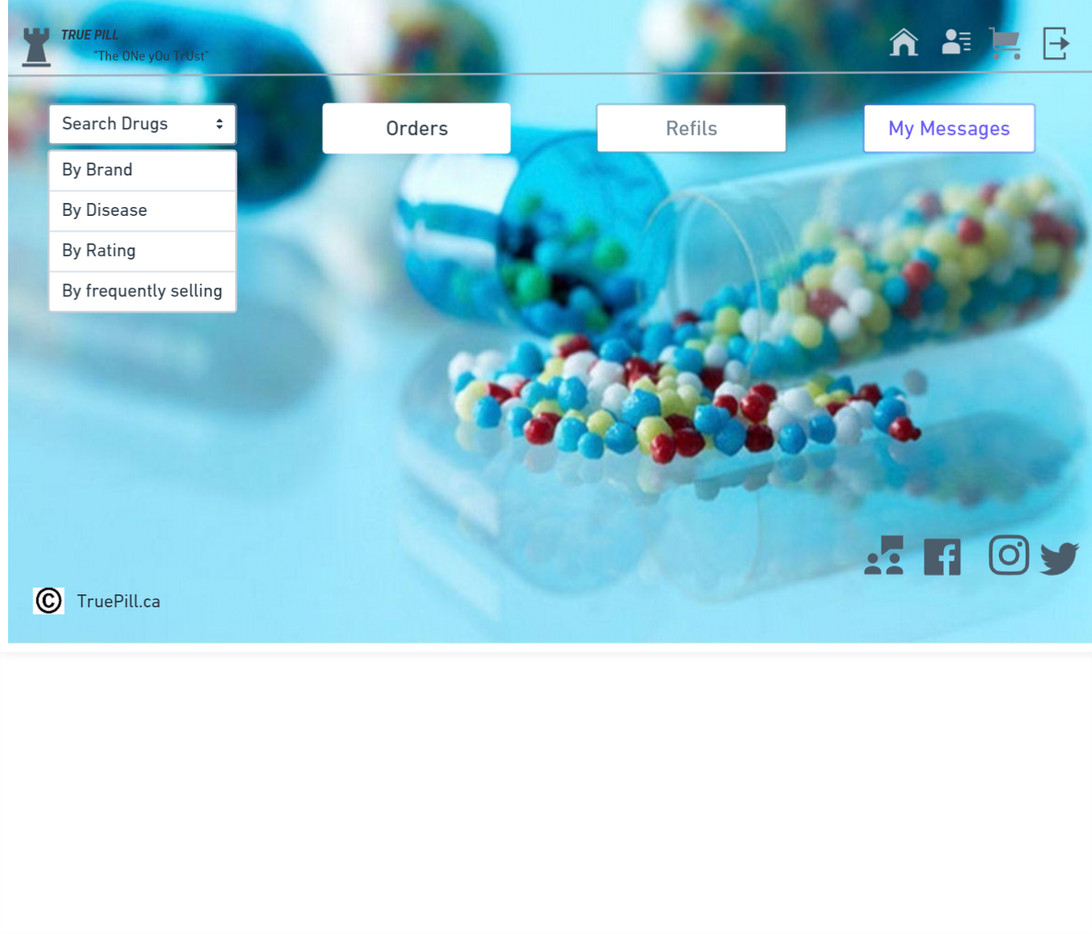

* The Pharmacist would be able to Search Products, Sale, Manage the Orders(Cart) and Manage Inventory(In Refills)
* The orders placed by a particular pharmacist would be listed out in the Cart tab, where we could Add/ delete a product before we checkout and finally Proceed to checkout and pay, get a copy of the receipt.

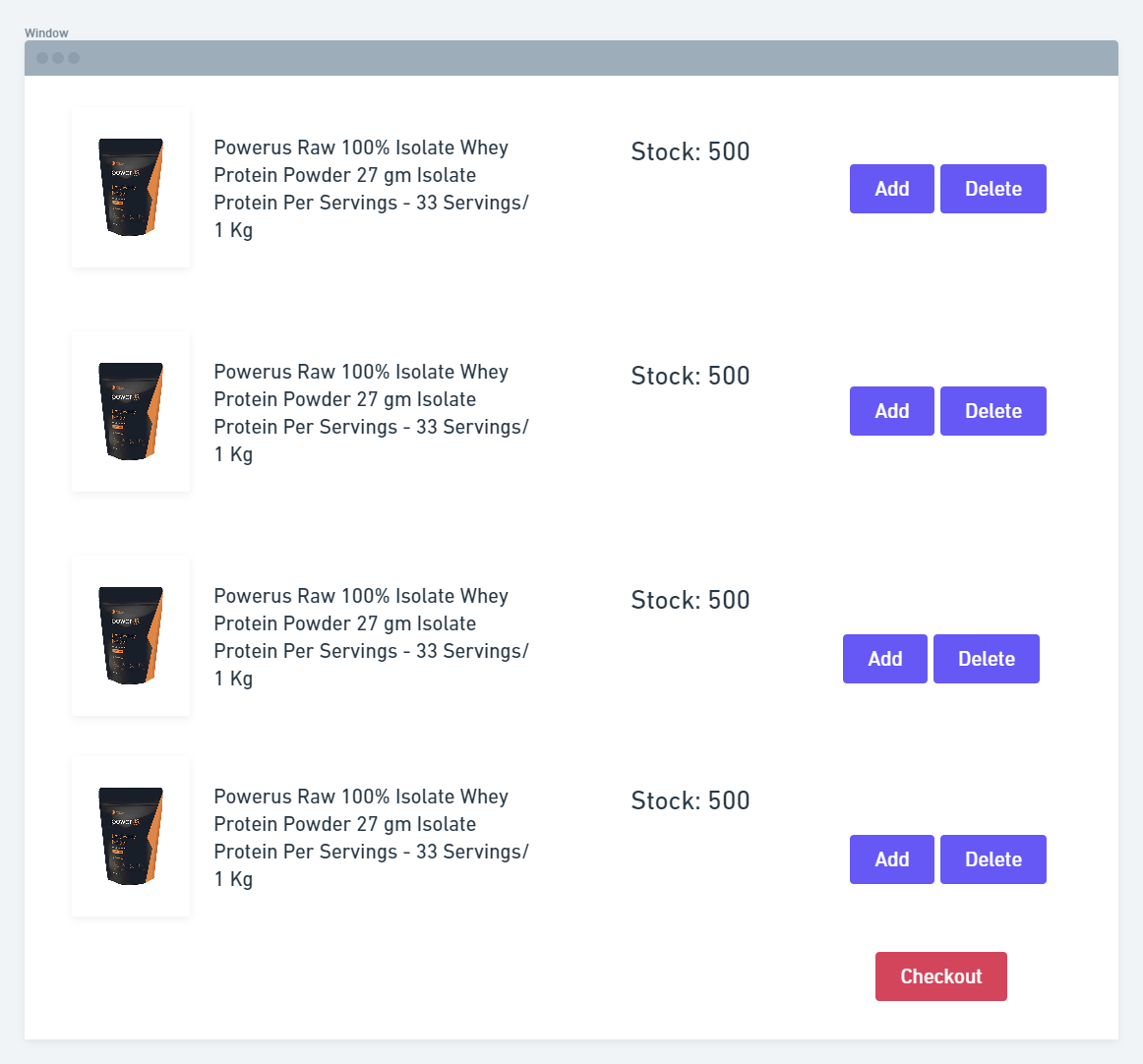

* Pharmacists can also update the inventory from the refills tab. When a pharmacist has any item out of stock and wanted to place an order with the supplier, that particular list would be updated through the Refills tab, where the pharmacist could customize the number of products needed.

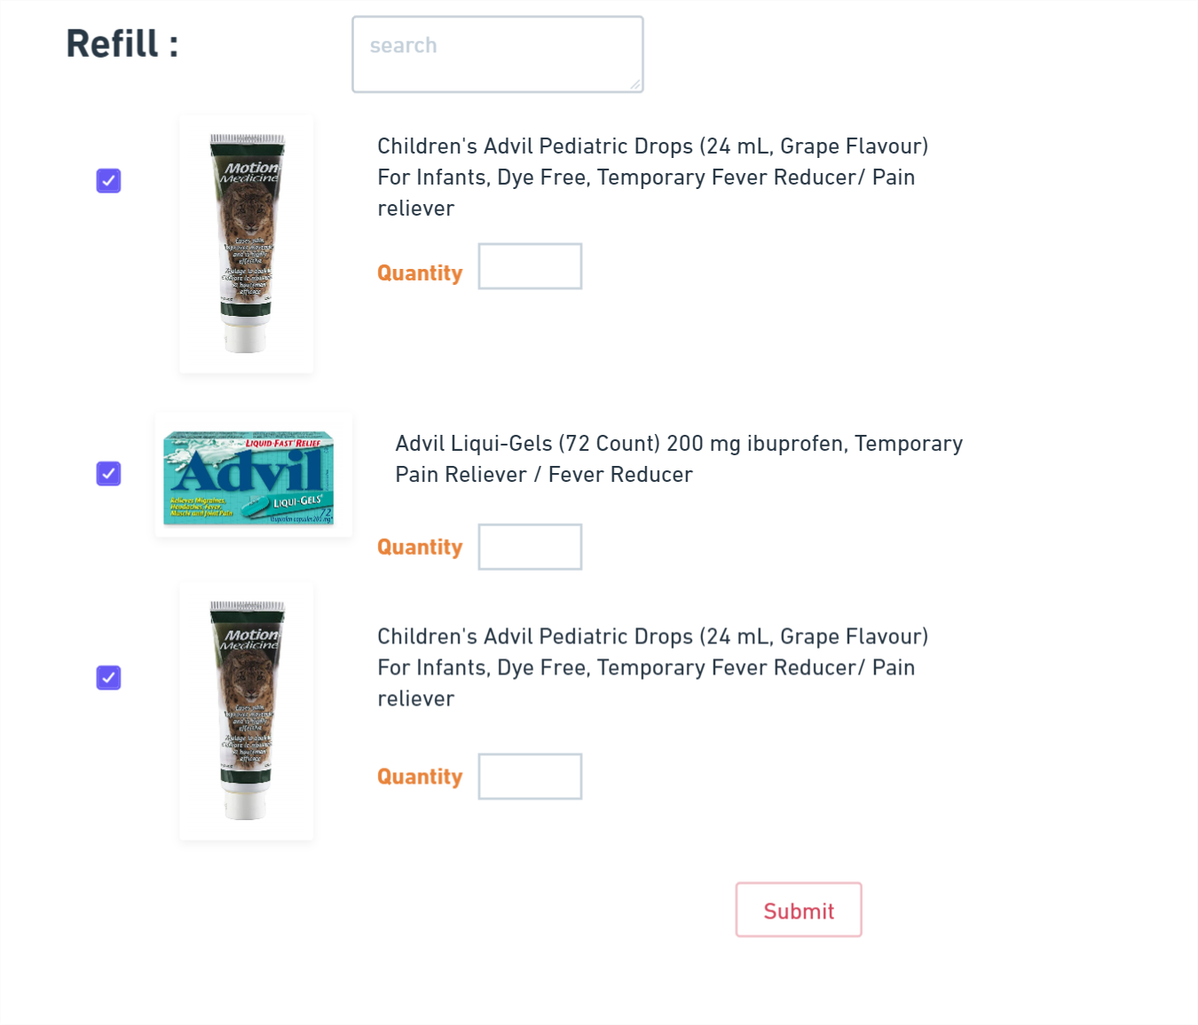

When the logged in user is an Admin

**string sql= select * from admin where username==?&& password==?**

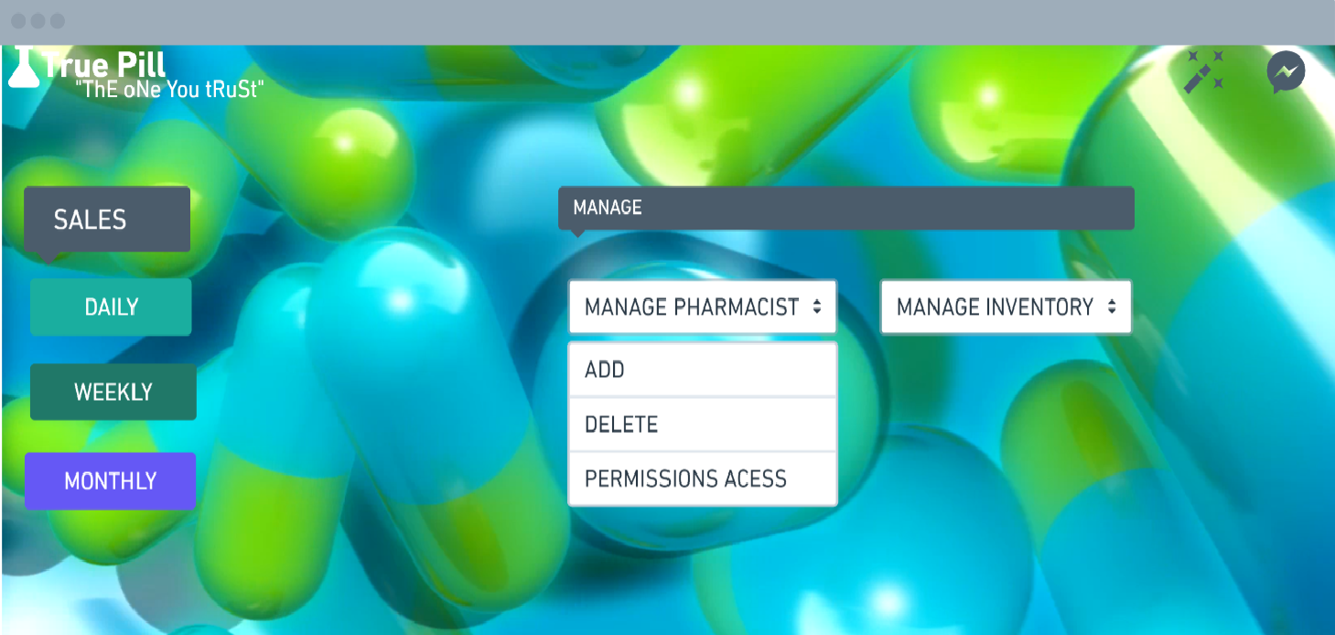

* Admin will have to Approve the Inventory requirements which the Pharmacist has added, Only then the orders would go to the Suppliers and once the orders are being obtained from suppliers, the pharmacist will update the inventory list with the new stock.
* Admin will get the Sales Reports on the Daily, Weekly and Monthly basis.

When the User Logged in is an SuperAdmin(Executive Manager)

**string sql= select * from superadmin where username==?&& password==?**

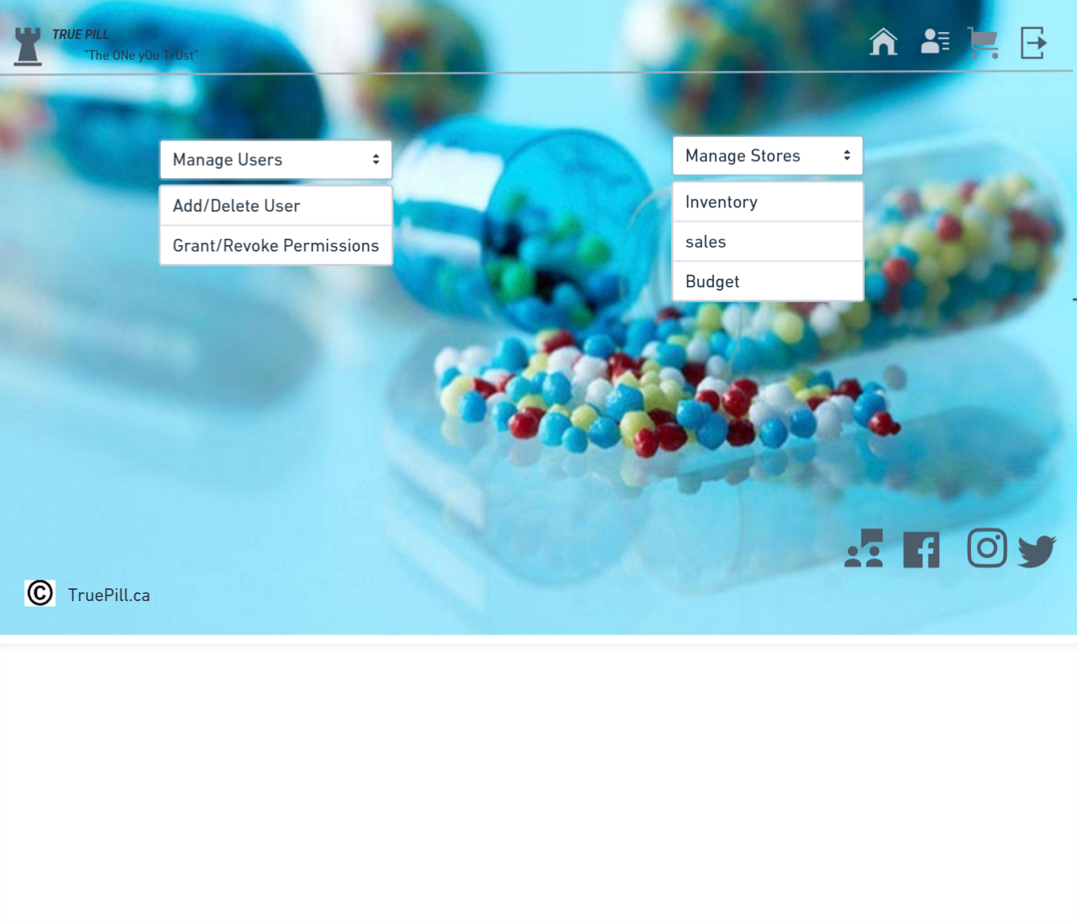

The Super Admin/Executive Manager will be able to Add/Delete the Users, Provide Permissions to the users. Also multiple stores can be managed by each category such as the Inventory, Sales, Budget for each store depending on the Id and the store location.